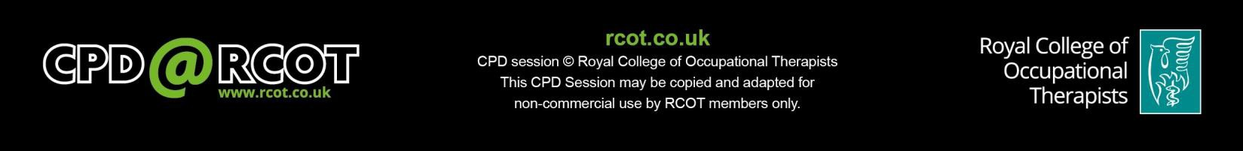

what is YOUR role?
CPD@RCOT Short Course
Work as a health outcome:
Group Session – Facilitator’s Guide

Name of Facilitator: Click or tap here to enter text.

This guide is designed to help you, as the facilitator, support participants with their learning during the group session of the CPD@RCOT Short Course.

Facilitator guide introduction
Thank you for being the group session facilitator for the CPD@RCOT Short Course ‘Work as a health outcome: what is YOUR role?’.

This guide will help you to understand the role of a facilitator. It gives you some suggestions on how to support participants, and to help them make the most of the discussions. It is intended for professionals at Career Levels 3 to 5 of the Facilitation of Learning Pillar of Practice (RCOT Career Development Framework). If you are at a higher Facilitation of Learning Career Level, the guide should also support you if you wish to refresh your knowledge of the subject matter.

According to the Cambridge dictionary, a facilitator is “someone who helps a person or organisation do something more easily or find the answer to a problem, by discussing things and suggesting ways of doing things” (Cambridge University Press, 2019).

This is exactly what you will be doing in the group session: your role will be to enable the discussions and encourage participants to think critically to enrich the debate.
You do not need special skills or previous knowledge of the topic. You can participate in all the group activities. You just need to bring your interest and enthusiasm to the room!

CPD@RCOT Short Courses can be delivered to a group or can be taken on your own. If you are on your own, you are your own course facilitator and this guide will be particularly relevant to you.

Preparing for the group session

Familiarise yourself with the course

Before the group session takes place, review the pre-work reading and activities. Compare the group session activities to the PowerPoint presentation. While doing so, study the activity notes in this guide.

Review in your mind what you want to say at each stage of the group session. Write down any questions, examples or scenarios from your own practice that are relevant to the activities. You can use these as a starting point for discussions if the group needs encouragement to engage.

Plan according to group size

This course is designed for participants to work on case studies in small groups, up to a maximum of five groups. Depending on the total number of participants, small groups may be a minimum of two people each. You do not need to use all the case studies, though, and the small groups will work better with a minimum of three people each. If there will be more than six people in each small group (that is, a total of more than 30 participants), you may judge the session will work better as two separate events.

A simple way to divide people randomly into groups is to count off individuals according to the number of groups. For example, if the number of participants is best divided into three groups, sequentially assign each person a number 1, 2, 3, 1, 2, 3 and so on.

Ask each group to appoint a recorder, who notes down a summary of the key discussion ideas with the agreement of the group. The recorder may or may not be the person to report back to the whole group.

As facilitator, you have access to extra information to ask each group about their case study (see ‘Resources’ section below). For this reason, your role will be more successful if you circulate from group to group rather participating in one group only.

Planning according to group needs

Before the group session takes place, check if any of the participants has special needs or requires specific assistance to access the course. Some suggestions to support assistance are given in this section.

Disability Rights UK has developed a Factsheet for Adjustments for a considerable number of special needs. The document offers a list of adjustments and approaches to improve communication.

Other charities have more information on specific needs. For example, the following guidance is available:

- Action on Hearing Loss: Communication tips for the general public

- Hearing Link: How to communicate with a hearing impaired person

- Royal National Institute of Blind People: Guide on how to meet, greet and guide a blind or partially sighted person

- British Dyslexia Association Advice for Educators: What do I need to know as a teacher?

- National Autistic Society Communication tips, so you can communicate more effectively They also provide Communication tools to improve understanding.

Appoint a timekeeper

Each section of the group session is timed so that the whole session does not over- run. As facilitator and participant, it is difficult to keep track of the time for each section as well. Appoint a timekeeper before the course starts, or at the beginning of the group session. It is helpful for the timekeeper to give a two minute warning before the end of each activity (and see notes below).

Resources you will need for a face to face session

Find out the details of the housekeeping points described in the welcome section on page 4 if you do not know them already.

Print out the case studies, single sided, at the end of this guide. Have these ready to hand out to the small groups during the session. Print out the ‘Case Studies crib sheet’ for yourself. This gives extra information for small groups to consider about their case study, and the points to ask during Activity 2, when the small groups come together to discuss the case studies together.

Have paper and pens available for each group. Prepare a piece of paper to circulate at the beginning, so that participants can record their contact details, if you do not have them already. If there are late-comers, ensure they record their details.

Prepare a way of recording and if possible, displaying, the discussion points generated by the whole group. This can be on a flipchart, post it notes, or you can write notes on paper or type them on a laptop or tablet.

If you are recording on paper, take photographs of the points that have been generated. After the course, send these out to the group members using the details participants provided at the beginning.

For guidance on running a remote group session, contact prof.dev@rcot.co.uk

Guidance for sole learners

CPD@RCOT Short Courses can be taken individually. In this case, you are the course facilitator and timekeeper. Use the Power Point presentation whilst completing the course and follow the “Facilitating the group session” instructions.
Take notes and ask yourself questions at any point of the Short Course. Record what you are learning and pay attention to the time you spend on each activity.
Consider sharing your thoughts and discussing any possible questions with your supervisor, and debate what you have learned with work colleagues / fellow occupational therapists.

Comments and complaints

If a participant feels uncomfortable with any of the activities, or has general comments or complaints about the course, advise them to send an email to prof.dev@rcot.co.uk. We are happy to receive suggestions or concerns and to make changes as appropriate.

Facilitating the group session
- Welcome (Slide 1: 3 minutes) Welcome the group to the session:
  - Introduce yourself if you are not known already to all attendees by giving your name, your job title, your organisation and, in one brief sentence, your interest in the course.

  - If you do not already have everyone’s details, circulate your paper for people to write their names and email addresses. Explain that this is to circulate the shared discussion points that are generated from the session.

  - If the course is being held outside the normal premises of work for any of the participants, go through housekeeping:
    - location of toilets;
    - whether there is a planned fire alarm;
    - fire exits;
    - where to congregate if fire alarm activates.

  - Nominate a timekeeper if this has not been decided before the session starts.

  - Encourage participants to bring their practice experience to the discussions.

  - Remind participants of the following:
- Only offer information or experiences they feel comfortable about sharing.
- They must act within their professional codes of conduct.
- Whatever is discussed in the group session is confidential.
- If they have any concerns about work as a health outcome, the workbook provides guidance on what to do (page 2).

- Learning Outcomes (Slides 2-4: 2 minutes)

  - Briefly review what learners will be able to do as a result of taking this course.

**Now divide the participants into small groups. Hand out one case study to each group. Explain that the case studies describe different scenarios and questions to consider and answer together. Each group needs to appoint a recorder to note down the answers. Each group will be reporting back to the whole group, so the groups may want to appoint a separate reporter.**

- Activity 1 – Apply your learning to Case Studies (Slide 5: 20 minutes) Actions for the small groups as described in the workbook:
“Working in the small group assigned by your facilitator:

  - Read the case study you have been given.
  - Discuss the questions about the case study with your small group, using your notes and learning from the individual activities.
  - Come to a consensus with your small group about the actions you would take with your Case Study.”

Actions for you:
- Circulate from group to group, listen to the discussion, offer the extra prompts on your crib sheet as appropriate.

- Remind the groups if necessary to record the answers to their questions, and that they will be reporting back to the whole group at the end of the activity.

- Activity 2 – Expand on the Case Studies (Slide 6: 20 minutes) Actions for the small groups as described in the workbook:
“Working with the whole group:

  - Share your Case Study and the actions your small group decided on.
  - Discuss as a whole group the further questions raised by your facilitator.”

Actions for you:
- Bring the whole group back together.

- Ask the reporter from each group to read out their case study and report on the answers to their questions. Guide the reporter to keep this relatively brief. Record any key general points that arise.

- After all groups have reported back, start a whole-group discussion about the points on your Case Studies crib sheet. Have some ideas of your own ready to get the discussion started. Record any key general points that arise.

- At the end of the allotted time, ask participants to return to their small groups.

- Activity 3 – Start to think about your own practice (Slide 7: 10 minutes) Actions for the small groups as described in the workbook:
“Working in your small group again, discuss how you will now support people with work within your own practice. What actions will you take to support people with work?”

Actions for you:
Circulate around the groups, encouraging them to think about their own practice, service users, and resources available to them. Have one or two thoughts about your own practice to offer to get things moving if people are stuck.

- Conclusion (Slide 8: 5 minutes)

- Concluding points to offer:
  - Employment is an important determinant of health.
  - For many people, it is important to -
- Enquire about their work situation,
- Consider the benefits and barriers to employment for them and
- Consider if adjustments or modifications would be possible.
  - The Equalities legislation offers specific protection for people with protected characteristics. This can help when thinking about work support plans.

- Remind participants there are further resources provided on pages 10-12 of the course workbook.

- Remind participants to complete their certificate at the back of the workbook.

- Allow a few minutes for participants to record immediate reflections and plans of action on page 9 of the workbook. Encourage them to return to page 9 in the next few days, and not longer than a week, to review their learning points and add further thoughts and ideas.

- Ask participants to send feedback to RCOT.

- Thank participants for attending and their engagement.

Post-course follow up
  - Distribute the discussion points to all participants, using the contact details you gathered at the beginning of the course.

  - To comply with GDPR, securely destroy the contacts paper when you have circulated shared learning points.

  - As possible after the course, complete the Facilitation reflection on the next page. Then complete your course facilitator certificate on the following page. File these pages in your CPD portfolio.

  - Send feedback to RCOT on the course using the feedback form or send suggestions to Prof.Dev@rcot.co.uk.

Facilitation reflection
Work as a health outcome: what is YOUR role?

Date: | Click or tap here to enter text.

Did you have concerns about facilitating the course before you started? How realistic were these in retrospect?

Consider what went well. What were the elements that made these aspects work? If you were to facilitate again, how would you make sure you include these elements?

Review what you would do differently next time. What do you want to change and why? If you were to facilitate again, what would you put in place to make this happen?

Do you have any unanswered questions about facilitating the learning of others? Who could you discuss these questions with?

Record your reflective learning points on facilitating the learning of others. If you have more than three, add them on the back of the page.

My reflective learning points on facilitating the CPD@RCOT Short Course ‘Work as a health outcome: what is YOUR role?’
1. Click or tap here to enter text.
2. Click or tap here to enter text.
3. Click or tap here to enter text.

RCOT would appreciate your feedback so that we can make improvements for future participants. Please fill our feedback form or send suggestions to Prof.Dev@rcot.co.uk. If you have any complaints, send an email to RCOTApprovedLearning@rcot.co.uk.

This is to certify that:

CPD@RCOT
Certificate of Facilitation of Learning

Click or tap here to enter text.

facilitated the CPD@RCOT Short Course on
Click or tap here to enter text.

Work as a health outcome: what is YOUR role?

The learning outcomes for this course are to:
- Understand the links between good quality employment and good health, and apply your understanding to support service users into paid work.
- Appropriately and sensitively ask people about their employment aspirations, so that you can signpost them on for further support to meet their employment needs.
- Evaluate your current and future practice in relation to work as a health outcome, to improve the quality of your practice and service delivery.

Work as a Health Outcome – Case Study 1

Struggling to remain in work with MSK conditions

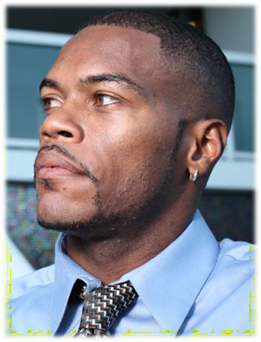
When asked about work, he disclosed that he was struggling and had been taking repeated short-term sick leave. He is struggling with being on his feet all day. His husband is encouraging him to resign from work to give him more time to recover and plan an upcoming
house move.
Credit: felixcasio_info
Following surgery, he had six sessions of physiotherapy. When he attended follow-up he was withdrawn, depressed and significantly
less engaged.
Abiaye, an NHS care of the elderly doctor aged 38 who lives in Scotland, fell from a ladder while decorating at home.

He prolapsed a disc and over the next month developed progressive nerve compression. He eventually presented in clinic with cauda equina syndrome, was rapidly admitted and underwent complete
disc resection.

- What aspects of this case do you need to consider when you are supporting Abiaye in regard to work?

- What are the benefits of work for Abiaye?

- List the barriers to work for Abiaye.

- Would workplace reasonable adjustments be possible? What might these adjustments be?

- What current options exist for Abiaye to return to work? What signposting can you provide for Abiaye?

Work as a Health Outcome – Case Study 2

Long term unemployed, drug and mental health problems

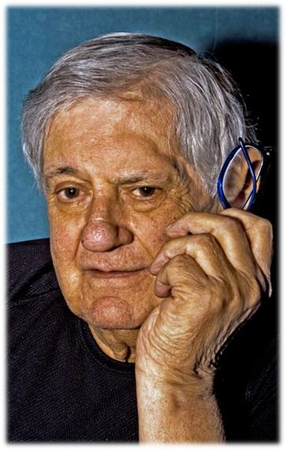
Credit: felixcasio_info
When Luis was discharged from hospital he felt he wasn’t ready for
employment as he lacks confidence in new environments. He is currently living in sheltered housing.
He stayed in hospital for approximately two and a half years progressing through the clinic where staff looked at his recovery goals. He has a particular passion for music and art. Occupational therapists were able to link him to a community music project where
he became a volunteer.
Luis is in his early 50s and has been sectioned under the Mental Health Act in England due to assaults on others whilst taking drugs. He has spent long periods of his life homeless and earning money as
a sex worker. He is HIV positive.

- What aspects of this case do you need to consider when you are supporting Luis in regard to work?

- What are the benefits of work for Luis?

- List the barriers to work for Luis.

- Would workplace reasonable adjustments be possible? What might these adjustments be?

- What current options exist for Luis starting to work? What signposting can you provide for Luis?

Work as a Health Outcome – Case Study 3

Older worker and carer, just diagnosed

Credit: vasic_info
She has recently been diagnosed with breast cancer. She is due to have surgery, chemotherapy and radiotherapy. She is keen to continue working. She is unsure of how to have a conversation with her employer. She is also very worried about her upcoming divorce. She has been separated from her husband for several
years and is worried about money.
Sabah, aged 60, is a Muslim woman from Iran who works as a university administrator balancing 25 hours of work a week with caring responsibilities for her elderly mother. She is a UK citizen
and has been resident for 40 years.

- What aspects of this case do you need to consider when you are supporting Sabah in regard to work?

- What are the benefits of work for Sabah?

- List the barriers to work for Sabah.

- Would workplace reasonable adjustments be possible? What might these adjustments be?

- What current options exist for Sabah continuing to work? What signposting can you provide for Sabah?

Work as a Health Outcome – Case Study 4

Signed off sick short term, mental health

Kalena is a trans woman living in Northern Ireland, aged 42. She is from Czechoslovakia and her first language is not English. She has settled status from the EU Settlement Scheme. She works full time as a server in a bar. She is diagnosed with bi-polar disorder and is currently accessing mental health services. Ten days ago she sustained whiplash from an RTA.

Kalena has reported that she is finding life very hard to cope with at the moment. She is in rent arrears, has two young children, and coping with neck pain. Her partner recently left her after being together for ten years.
Credit: 24063489
She has been experiencing disruptive mood swings and is feeling angry at work. She feels that she cannot speak to her manager.

She has been signed off work sick for ten days now and wants to be off for longer.

- What aspects of this case do you need to consider when you are supporting Kalena in regard to work?

- What are the benefits of work for Kalena?

- List the barriers to work for Kalena.

- Would workplace reasonable adjustments be possible? What might these adjustments be?

- What current options exist for Kalena to return to work? What signposting can you provide for Kalena?

Work as a Health Outcome – Case Study 5

Young person signed off sick long term

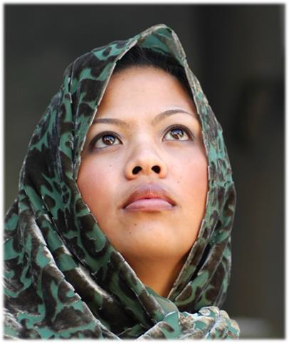

Nadia is 19 years old, a Welsh Muslim who lives in a house share in Cardiff. Her family also live in Cardiff but she is estranged from them. She has been signed off sick from her job as a social work assistant for four months due to her long-term conditions. She has reduced lung function and gets repeated chest infections. She also has Crohn’s disease and after an ileostomy has fibromyalgia and post-surgery trauma.

She feels down, stressed and aches everywhere. She has also just found out she is four months pregnant.
Credit: Inspir8tion
She has a new line manager who she feels is bullying her and is thinking of contacting her union for support.

- What aspects of this case do you need to consider when you are supporting Nadia in regard to work?

- What are the benefits of work for Nadia?

- List the barriers to work for Nadia.

- Would workplace reasonable adjustments be possible? What might these adjustments be?

- What current options exist for Nadia to return to work? What signposting can you provide for Nadia?

Work as a Health Outcome

Case studies crib sheet

ACTIVITY 1 – Apply your Learning to Case Studies

Case study 1 – Abiaye: Struggling to remain in work with MSK conditions

Specific questions, considerations and prompts

  - What are the particular risks for Abiaye about permanently leaving work?
  - Do you think Abiaye would have access to occupational health?
  - How could the Equalities legislation help Abiaye?
  - Is there any MSK specific guidance or sources of support you are aware of for Abiaye?

Case study 2 – Luis: Long term unemployed, drug and mental health problems

Specific questions, considerations and prompts

  - What are the particular risks for Luis about being long term unemployed?
  - Do you think anything specific may help with his lack of work experience?
  - What else may help Luis find work despite his criminal record?
  - Is there any mental health and/or criminal justice specific guidance or sources of support you are aware of for Luis?

Case study 3 – Sabah, Older worker and carer, just diagnosed

Specific questions, considerations and prompts

  - Sabah faces the balance between work, caring responsibilities and cancer treatment - how could she be supported to manage this?
  - How could the Equalities legislation help Sabah?
  - Are there any cancer specific guidance or sources of support you are aware of for Sabah?

Case study 4 – Kalena, Signed off sick short term, mental health

Specific questions, considerations and prompts
  - What are the particular risks for Kalena about extending her sick leave?
  - What may help speed her return to work?
  - What support may be available from her mental health services?
  - How could the Equalities legislation help Kalena?

Case study 5 – Nadia, Young person signed off sick long term

Specific questions, considerations and prompts

- What are the particular risks for Nadia losing her job?
- What pregnancy support may Nadia need?
- Could the Equalities legislation help Nadia?

ACTIVITY 2 – Expand on the Case Studies
Prompts for overall discussion

- In addition to disability, what are the other protected characteristics of the Equalities legislation that may help with return to work?

- What types of employers are more likely to have access to occupational health?

- How could you help someone think about the difficult parts of their job, the easy parts and the part in the middle that could be adapted in some way?

- How important work is to the person and how confident they feel about return to work are important issues -how might you ask someone about these?

