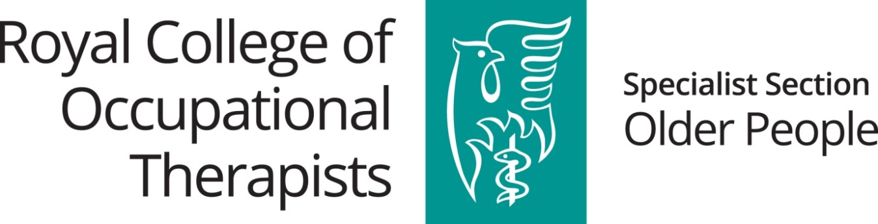

RCOT Specialist Section Older People 2020
Country Award

Historically, the RCOT Specialist Section Older People each year offers the opportunity to our membership to apply for funding to attend the RCOT Annual Conference. As the annual conference is currently under review, the specialist section is offering instead, an award to support member’s continuing professional development (CPD).

Four awards of £300 are available to one member from each of the four nations of the United Kingdom (UK), to enable participation in an element of CPD that will support, enhance or benefit your practice with older people.

Successful applicants will be expected to share their learning from the CPD event/opportunity undertaken, by preparing a short article for publication in the specialist section newsletter.

All applicants MUST be RCOT Specialist Section Older People members and all applicants MUST submit their application using the template below.

No award money will be paid in advance of the CPD opportunity. Money from the RCOT Specialist Section Older People treasurer, Debra Jeffrey (debrajeffery@nhs.net), can only be paid to successful applicants where receipt(s) of payment are provided and evidence of successful completion of CPD submitted (please refer to further terms of award, below).

All applications should be sent to Dr Fiona Maclean, R&D Officer, RCOT Specialist Section Older People, via email (fmaclean@qmu.ac.uk).

No feedback will be provided on applications that are unsuccessful, and the decision of the NEC Specialist Section Older People, connected to award winners, is final.

To Apply for the Country Award

Please submit your application by midnight on FRIDAY 25th September 2020 to Dr Fiona Maclean, R&D Officer, via email (fmaclean@qmu.ac.uk). Late applications will not be accepted.

Terms of the award include:
- Travel and accommodation costs will not be considered
- Where conference/event attendance is included, this should be costed at an ‘early bird’ rate
- Non-transferable name
- RCOTSS-OP members only can apply
- Only the submission and completion of applications, using the template below, in full and on time, will be considered
- A short (500 word) summary of the CPD opportunity undertaken should be prepared and submitted for publication in the specialist section newsletter.

Dr Fiona Maclean, RCOTSS-OP R&D Officer

RCOT Specialist Section Older People 2020
Country Award

Application Template

NAME:

RCOT Membership No.:
RCOT Specialist Section Membership No.:
State the nation of the UK in which you are resident (N.I., Wales, England, Scotland), including postal address:
E-mail address:

Mobile Phone:
Estimated cost of the CPD event/opportunity & briefly outline how this will be supported by your employer:

- Please summarise the continuing professional development event/opportunity you intend to undertake (no more than 100 words):

- Please outline in what way this CPD event/opportunity will benefit older people (no more than 250 words), e.g. how will this CPD opportunity enable engagement with older people, in what way does it involve older people:

- Outline how you propose to share your learning from the CPD event/opportunity you propose to undertake with colleagues, older people and/or the profession of occupational therapy more generally (no more than 250 words):
- What three learning outcomes do you intend to achieve from the CPD learning opportunity?

